**PROJECT REPORT**

Smart Farmer-IOT Enabled Smart Farming Application

### Submitted by

**Team ID:** PNT2022TMI14849

**Team Leader:**  Marzouq Ebrahim.H

**Team Members:** Hema vasanth.S.V

Ramkumar.B

Logesh.K.S

**TABLE OF CONTENTS**

## INTRODUCTION

* 1. PROJECT OVERVIEW
  2. PURPOSE

## LITERATURE SURVEY

|  |  |  |  |
| --- | --- | --- | --- |
|  | 2.1 | EXISTING PROBLEM |  |
| ` | 2.2 | REFERENCES |  |
|  |  |  |  |
|  | 2.3 | PROBLEM STATEMENT | DEFINITION |

1. **IDEATION**
   1. EMPATHY MAP CANVAS
   2. IDEATION & BRAINSTORMING

INTRODUCTION

Project overview

Purpose

LITRETURE SURVEY

Existing problem

References

Problem statement definition

IDEATION

Empathy map canvas

Ideation & Brainstorming

Proposed solution

Problem solution fit

* 1. PROPOSED SOLUTION
  2. PROBLEM SOLUTION FIT

## REQUIREMENT ANALYSIS

* 1. FUNCTIONAL REQUIREMENTS
  2. NON-FUNCTIONAL REQUIREMENTS

## PROJECT DESIGN

* 1. DATA FLOW DIAGRAM
  2. SOLUTION & TECHNICAL ARCHITECTURE
  3. USER STORIES

## PROJECT PLANNING AND SCHEDULING

1. PROJECT PLANNING AND SCHEDULING
   1. SPRINT PLANNING AND ESTIMATION
   2. SPRINT DELIVERY SCHEDULE

## CODING AND SOLUTIONING

1. **TESTING**
   1. TEST CASES
   2. USER ACCEPTANCE TESTING
      1. DEFECT ANALYSIS
      2. TEST CASE ANALYSIS

## RESULTS

* 1. PERFORMANCE METRICS

## ADVANTAGES AND DISADVANTAGES

* 1. ADVANTAGES
  2. DISADVANTAGES

## CONCLUSION

### FUTURE SCOPE

**APPENDIX**

SOURCE CODE GITHUB PROJECT DEMO

# INTRODUCTION

## PROJECT OVERVIEW:

Smart farming is certainly a leading enabler in producing more food with less for an increasing world population. Smart farming enables increased yield through more efficient use of natural resources and inputs, and improved land and environmental management. While this is crucial to sustainably feeding the world’s growing population, there are other benefits that smart farming provides farmers and communities all around the world.

Conventional supply chains have been characterized by a power imbalance with farmers often having less power because they’ve had less information about how their product performs relative to customer requirements. Smart farming provides a vital link between all players in the supply chain by enabling the efficient and equitable flow of information and in doing so, facilitating better decision making. This has the potential to rebalance power and redistribute profits more equitably throughout the supply chain

## PURPOSE:

Smart farming helps farmers to better understand the important factors such as water, topography, aspect, vegetation and soil types. This allows farmers to determine the best uses of scarce resources within their production environment and manage these in an environmentally and economically sustainable manner.

One of the goals of smart farming is to make better use of the land and improve yields as a first step in solving world hunger.

# LITERATURE SURVEY

## EXISTING PROBLEM:

Agriculture is one of the most important aspects in India. Irrigation accounts for 55-70% of water usage in India. Water usage for irrigation is nearly 60%. Most of this water used is wasted. We can use soil moisture sensor as a solution for wastage of water. This is done by IOT devices. The IOT networks reduce human labor requirements on the farm. IOT uses wireless sensor networks for gathering information to monitor and control the activities. For monitoring the farm remotely, the end devices are equipped with soil moisture sensor, temperature sensor, etc. There is no means for farmers to have complete control over their farms and monitor the activity on the farm remotely. Here we try to provide a system that is cost effective and provides the functionalities that is required by the Indian farmers.

## REFERENCES:

* + 1. Joaquín Gutiérrez, Juan Francisco Villa- Medina, Aracely López-Guzmán, and Miguel Ángel Porta Gándara, “Smartphone Irrigation Sensor”, Proceedings of IEEE Sensors Journal Sensors 2015, P.3-4
    2. F. Viani, M. Bertolli, M. Salucci, “Low- Cost Wireless Monitoring and Decision Support for Water Saving in Agricultu

re’, Proceedings of IEEE Sensors Journal, Vol 0, 2017, P.69.

* + 1. Jan Bauer and Nils Aschenbruck,” Design and Implementation of an Agricultural Monitoring System for Smart Farming”, Proceedings of IEEE IOT Vertical and Tropical Submit on Agriculture, 2018, P.978-982.
    2. Soumil Heble, Ajay Kumar, K.V.V. Durga Prasad, Soumya Samirana, P. Rajalakshmi, U. B. Desai” A Low Power IOT Network for Smart Agriculture”, Proceedings of Data Science Based Farming Support System for Sustainable Crop Production Under Climatic Changes, 2016, P.609-613.

An overview of the Smart Farmer - IOT Enabled Smart Farming Application is presented and an extensive survey on smart solution for crop growth using IOT is provided.

**2.3 PROBLEM STATEMENT DEFINITION:**

Farmers need to deal with many problems like coping with climate change, soil erosion and Biodiversity loss. To provide efficient decision support system using wireless sensors network which handle different activities of farm and gives useful information related to soil moisture, Temperature and Humidity content. Due to the weather condition, water level increasing Farmers get lot of distractions which is not good for agriculture.

IDEATION

EMPATHY MAP CANVAS

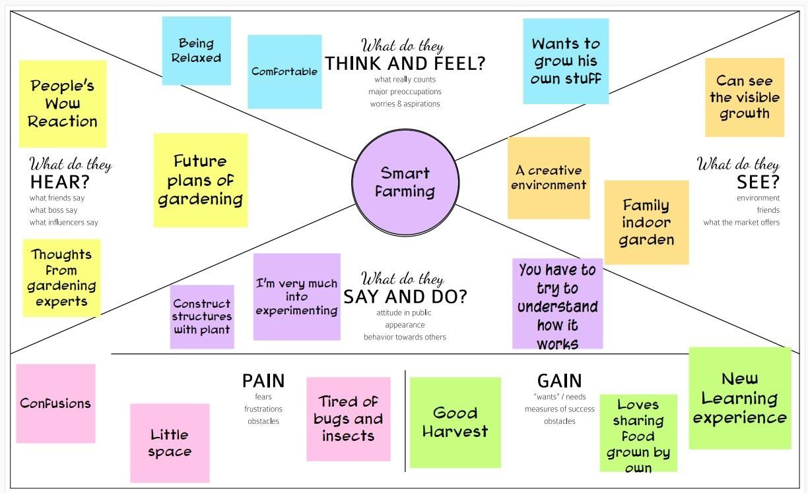

IDEATION AND BRAINSTORMING

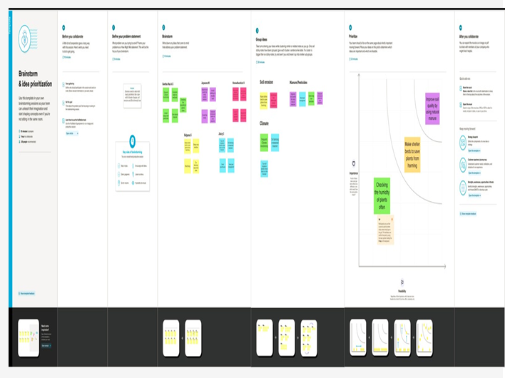

Proposed solution

|  |  |  |
| --- | --- | --- |
| **S. No.** | **Parameter** | **Description** |
| 1. | Problem Statement (Problem to be solved) | Overuse of pesticides and fertilizer in agricultural fields leads to destruction of the crop as well as reduces the efficiency of the field increasing the soil vulnerability towards pest. |
| 2. | Idea / Solution description | We can provide a solution by Smart Farming Application system that is built for monitoring the crop field with help of sensors and automating the irrigation system. |
| 3. | Novelty / Uniqueness | We can use IoT devices to provide solutions for the problem in a efficient way. We use Soil moisture level sensor to get the actual moisture content present in the soil. |
| 4. | Social Impact / Customer Satisfaction | This Application will help customers/farmers to better understand the important factors of farming such as water, vegetation and soil types. |
| 5. | Business Model (Revenue Model) | This application will give a revenue or profit about 40% of yearly expenditure. |
| 6. | Scalability of the Solution | Our project is capable to grow in the market as smart farming is an emerging technology now a days. |

PROBLEM SOLUTION FIT

|  |  |  |  |  |  |  |  |  |  |  |  |  |
| --- | --- | --- | --- | --- | --- | --- | --- | --- | --- | --- | --- | --- |
| **Project Design phase – I**    **Problem Solution fit**  **Project name: Smart Farmer – IoT Based Smart Farming Application Team Id :** PNT2022TMID14849     |  |  |  | | --- | --- | --- | | **1.Customer segments:-**    Types of Customers who are going to this project are   * Large Scale Farmers * Remote Farmers | **6.Customer constrains:-**    The customer needs a solution which will solve the problems in farming when he is in a remote location and that solution should fulfil the following needs.   * Cost efficient * Low power consumption * Time efficient | **5.Available solutions**    We can give solutions to this problem by using the Smart Farming Application which collects the Moisture level data from the field and operate in the basis of that moisture level. |      |  |  |  | | --- | --- | --- | | **2.Jobs to be done :-**    The Customers want to automate the irrigation process, reduce cost of manual workers and minimize the power consumption | **9.Problem route cause:-**    The route cause for Smart farming Application is farmer’s need to be feel comfortable. | **7.Behavior:-**    The customer needs to make a revolutionary change in farming by means of modern technologies. |      |  |  |  |  |  | | --- | --- | --- | --- | --- | |  | 3.Triggers:-  Farmers are facing many problems while farming in traditional manner. This triggers the Smart Farming Applications. |  | **10.Solution**:-    Our solution for this project is to give environment sustainable Product for the farming in modern era with reduced cost and with best efficiency. | 8.Channels of behavior:-  The channels of behavior recombines the ration of the following   * Online * Offline | | 4.Emotions:-  Farmers feel very relaxed and feel stressless while working in field. | |

REQUIREMENT ANALYSIS

FUNCTIONAL REQUIREMENTS:

Following are the functional requirements of the proposed solution.

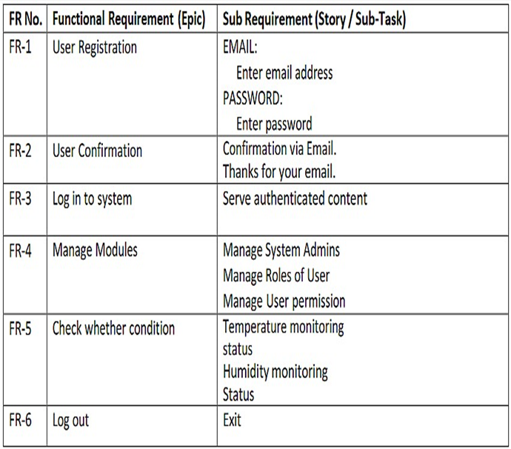

NON FUNCTIONAL REQUIREMENTS:

Following are the non functional requirements of the proposed solution.

|  |  |  |
| --- | --- | --- |
| **FR**  **No.** | **Non-Functional Requirement** | **Description** |
| NFR-1 | **Usability** | Time consumability is less, Productivity is high. |
| NFR-2 | **Security** | It has low level of security features due to integration of sensor data. |
| NFR-3 | **Reliability** | Data is more accurate and hence it is Reliable. |
| NFR-4 | **Performance** | Performance is high and highly productive. |
| NFR-5 | **Availability** | With permitted network connectivity the application is accessible |
| NFR-6 | **Scalability** | It is perfectly scalable many new constraints can be added |

PROJECT DESIGN

DATA FLOW DIAGRAM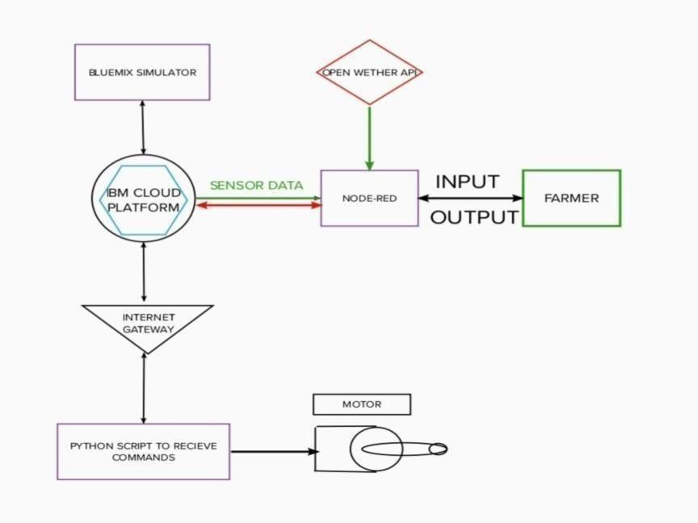

SOLUTION AND TECHNICAL ARCHITECTURE

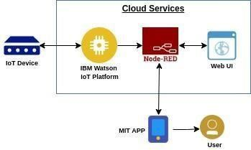

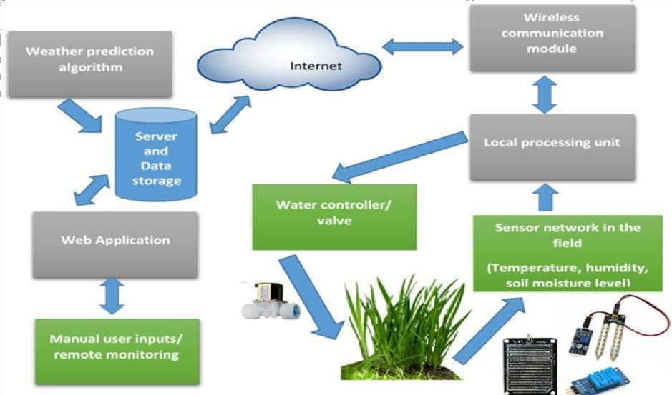

USER STORIES

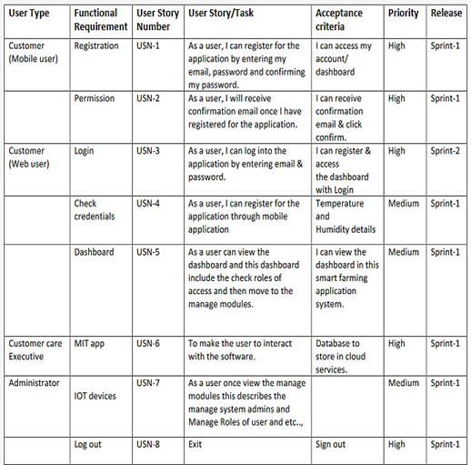

PROJECT PLANNING AND SCHEDULING

SPRINT PLANNING AND ESTIMATION

**Product Backlog, Sprint Schedule, and Estimation (4 Marks)**

|  |  |  |  |  |  |
| --- | --- | --- | --- | --- | --- |
| **Sprint** | **Functional**  **Requirement** **(Epic)** | **User**  **Story**  **Number** | **User Story / Task** | **Story**  **Points** | **Priority** |
| Sprint-1 | Simulation creation | USN-1 | Connect Sensors and Arduino with python code | 2 | High |
| Sprint-2 | Software | USN-2 | Creating device in the IBM  Watson  IoT platform, workflow for IoT scenarios using  Node-Red | 2 | High |

|  |  |  |  |  |  |  |
| --- | --- | --- | --- | --- | --- | --- |
| **Sprint** | **Total**  **Story**  **Points** | **Duration** | **Sprint Start Date** | **Sprint End**  **Date**  **(Planned)** | **Story Points**  **Completed**  **(as on**  **Planned End**  **Date)** | **Sprint Release**  **Date (Actual)** |
| Sprint-1 | 20 | 7 Days | 30 Oct 2022 | 06 Nov 2022 | 20 | 29 Oct 2022 |
| Sprint-2 | 20 | 9 Days | 31 Oct 2022 | 09 Nov 2022 |  | 05 Oct 2022 |

|  |  |  |  |  |  |
| --- | --- | --- | --- | --- | --- |
| Sprint-3 | MIT App  Inventor | USN-3 | Develop an application for the  Smart farmer project using MIT  App Inventor | 2 | High |
| Sprint-3 | Dashboard | USN-3 | Design the modules and test app | 2 | High |
| Sprint-4 | Web UI | USN-4 | To make the user to interact with the software | 2 | High |

**Project Tracker, Velocity & Burndown Chart: (4 Marks)**

|  |  |  |  |  |  |  |
| --- | --- | --- | --- | --- | --- | --- |
| Sprint-3 | 20 | 6 Days | 06 Nov 2022 | 13 Nov 2022 |  | 12 Oct 2022 |
| Sprint-4 | 20 | 6 Days | 11 Nov 2022 | 17 Nov 2022 |  | 15 Oct 2022 |

CODING AND SOLUTIONING

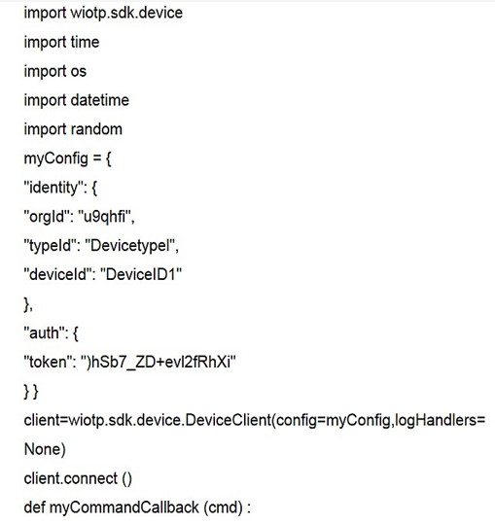

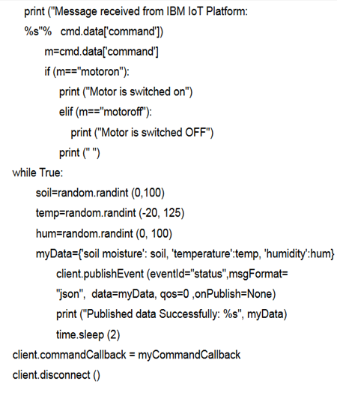

TESTING

TEST CASES

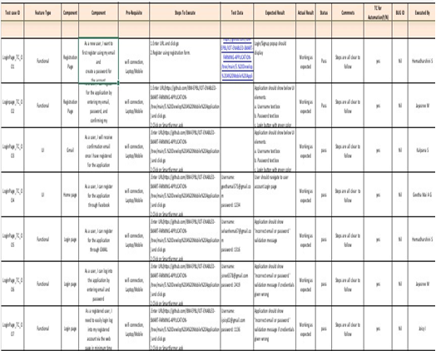

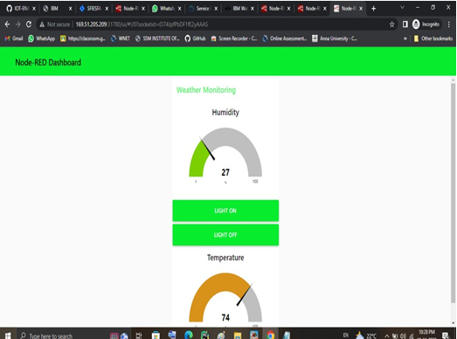

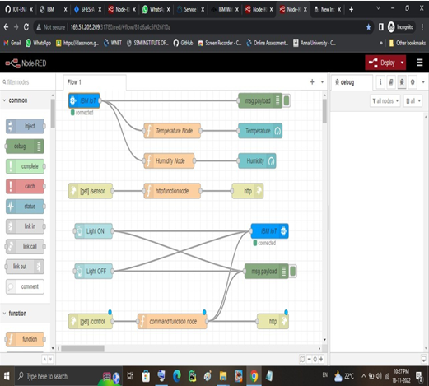

USER ACCEPTANCE TESTING

DEFECT ANALYSIS

This report shows the number of resolved or closed bugs at each severity level. And how they were resolved.

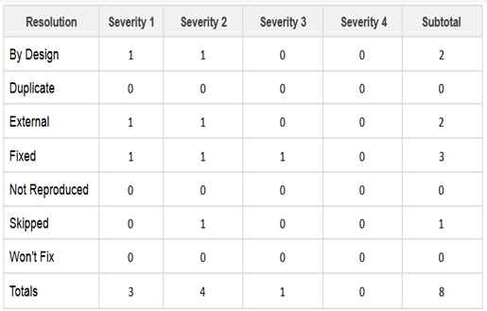

TEST CASE ANALYSIS

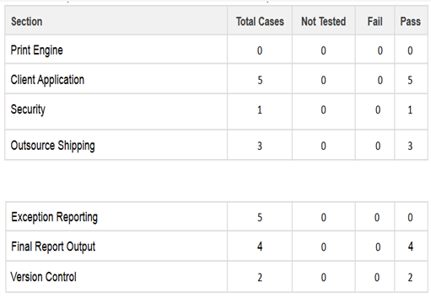

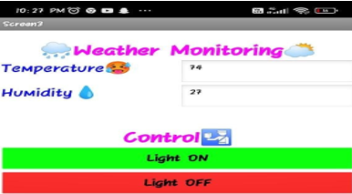

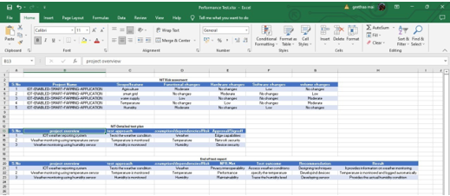

RESULTS

PERFORMANCE METRICES

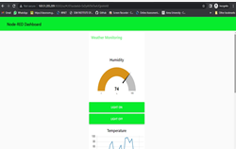

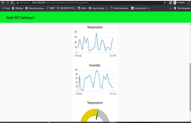

ADVANTAGES AND DISADVANTAGES

ADVANTAGES:

All the data like climatic conditions and changes in them, soil or crop conditions everything can be easily monitored.

Risk of crop damage can be lowered to a greater extent.

Many difficult challenges can be avoided making the process automated and the quality of crops can be maintained.

The process included in farming can be controlled using the web applications from anywhere, anytime.

A remote control system can help in working irrigation systemvalves dependent on schedule. Irrigating remote farm properties can be exceptionally troublesome and laborintensive. It gets hard to comprehend when the valves were started and whether the ideal measure of water was distributed.

Various solutions are available to monitor engine statistics and starting or stopping the engine.

When the client chooses to begin or stop the

motor, the program transmits a sign to the unit within seconds by means of a mobile phone system.

DISADVANTAGES

The smart agriculture needs availability of internet continuously. Rural part of most of the developing countries do not fulfil this requirement. Moreover internet connection is slower.

The smart farming based equipment require farmers to understand and learn the use of technology.

This is major challenge in adopting smart agriculture farming at large scale across the countries.

IOT devices need much money to implement.

Any faults in the sensors can cause great loss in the agriculture,due to wrong records and the actions of automated processes.

CONCLUSION:

Farmers can benefit greatly from an IoT-based smart agriculture system. As a result of the lack of irrigation, agriculture suffers. Climate factors such as humidity, temperature, and moisture can be adjusted dependent on the local environmental variables. This technology also detects animal invasions, which are a major cause of crop loss.

This technology aids in the scheduling of irrigation based on present data from the field and records from a climate source. It helps in deciding the farmer to whether to do irrigation or not to do. Continuous internet connectivity is required for continuous monitoring of data from sensors.

This also can be overcome by using GSM unit as an alternative of mobile app. By GSM, SMS can be sent to farmers phone.An IOT based smart agriculture system using Watson IOT platform, Watson simulator, IBM cloud and Node-RED are also provided.

FUTURE SCOPE

In future due to more demand of good and more farming in less time, for betterment of the crops and reducing the usage of extravagant resources like electricity and water IOT can be implemented in most of the places.We can create few more models of the same project ,so that the farmer can have information of a entire.We can update the this project by using solar power mechanism. So that the power supply from electric poles can be replaced with solar panels. It reduces the power line cost. It will be a one time investment. We can add solar fencing technology to this project.We can add camera feature so that the farmer can monitor his field in real time. This helps in avoiding thefts

APPENDIX:

SOURCE CODE:

